Annex JJ. Naive Bayes classification

Naive Bayes classification is considered to be supervised since naive Bayes classifiers are trained using labelled data, i. e. data that has been pre-categorized into the classes that are available for classification. Before deciding to apply the Bayes network for a particular task, the Bayes network’s advantages and drawbacks should be considered (Goštautaitė, 2019). Pilot experimental learning style simulation was done using GeNIe Academic Version 2.3.3828.0 (Figure 1.2.). Knowledge-based approach for network training was applied.
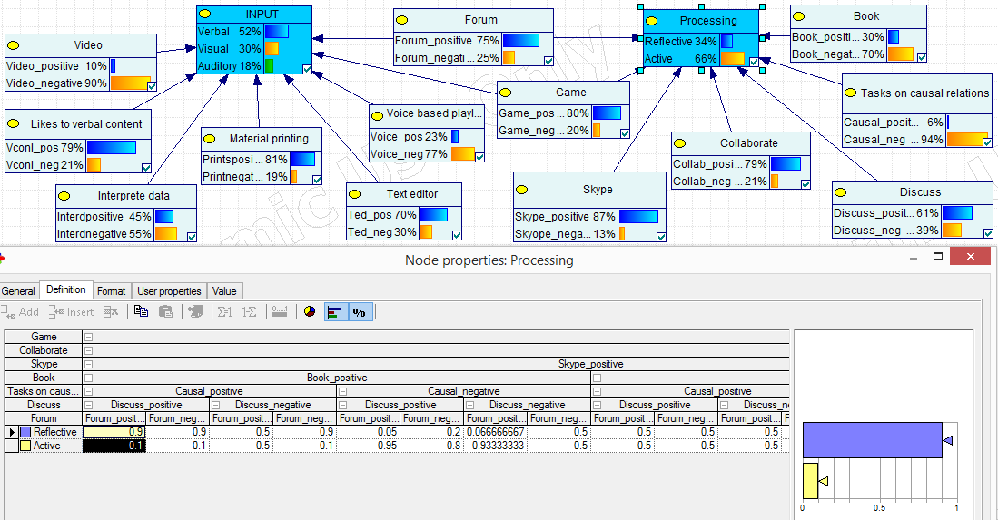
Fig. 1.2. Bayes network for modeling the learning style of a learner (made by the author)

